საბა მარღანია
II კურსი
პროექტი: აეროპორტი

მონაცემთა ბაზის შექმნა:
CREATE DATABASE Airport;

ცხრილების შექმნა:
CREATE TABLE aeroporti (
aeroportID int NOT NULL PRIMARY KEY,
dasaxeleba varchar (50) NOT NULL,
mgzavrisId int NOT NULL,
qalaqisID int NOT NULL,
tvitmpID int NOT NULL,
reisisID int NOT NULL,
);
CREATE TABLE bargi (
bargisID int NOT NULL PRIMARY KEY,
nivti1 varchar (50),
nivti2 varchar (50),
nivti3 varchar (50,
nivti4 varchar (50),
);
CREATE TABLE mgzavri (
mgzavrisID int NOT NULL PRIMARY KEY,
saxeli varchar (50) NOT NULL,
gvari varchar (50) NOT NULL,
piradiNo int NOT NULL,
bargiId int NOT NULL
);

CREATE TABLE piloti (
pilotiID int NOT NULL PRIMARY KEY,
saxeli varchar (50) NOT NULL,
gvari varchar (50) NOT NULL,
asaki int NOT NULL,
piradoba int NOT NULL,
);
CREATE TABLE qalaqi (
qalaqisID int NOT NULL PRIMARY KEY,
dasaxeleba varchar (50) NOT NULL,
mosaxleoba int NOT NULL,
saxelmwifo int NOT NULL,
);
CREATE TABLE reisi (
reisisID int NOT NULL PRIMARY KEY,
mimartuleba varchar (50) NOT NULL,
mgzavrebisRaod int NOT NULL,
afrenisDro date NOT NULL,
chasvlisDro date NOT NULL,
tvitmfrinavisID int NOT NULL
);

CREATE TABLE tvitmfrinavi (
tvitmfrinavisID int NOT NULL PRIMARY KEY,
dasaxeleba varchar (50) NOT NULL,
adglebisRaod int NOT NULL,
piloti int NOT NULL,
);

Table Diagram:

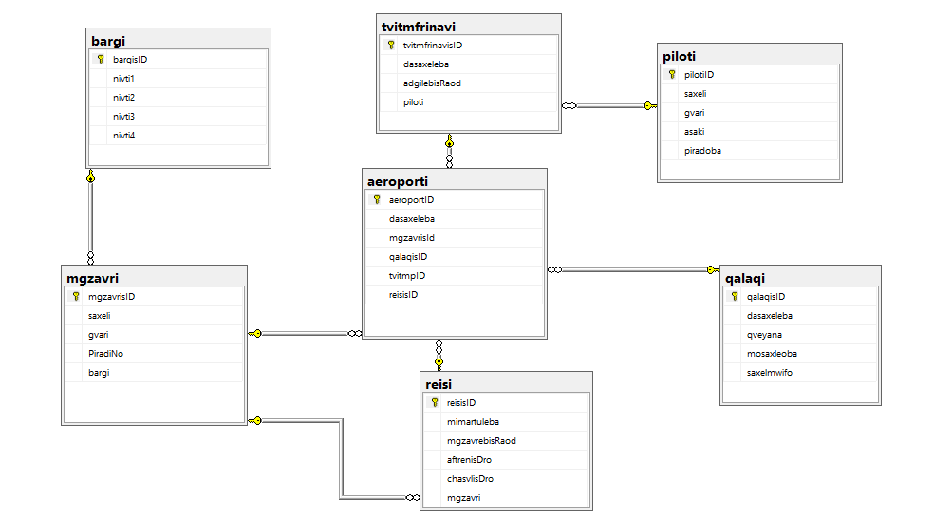

Monacemebis Shetana:

Piloti:
use Airport
INSERT INTO piloti(pilotiID,saxeli,gvari,asaki,piradoba) VALUES('1','Niko','Abashidze','30','1865204')
INSERT INTO piloti(pilotiID,saxeli,gvari,asaki,piradoba) VALUES('2','Saba','Lomidze','25','1865204')
INSERT INTO piloti(pilotiID,saxeli,gvari,asaki,piradoba) VALUES('3','Sandro','Margvelashvili','35','1865204')
INSERT INTO piloti(pilotiID,saxeli,gvari,asaki,piradoba) VALUES('4','Nika','Adamia','32','1865204')
INSERT INTO piloti(pilotiID,saxeli,gvari,asaki,piradoba) VALUES('5','Demetre','Vashalomidze','41','1865204')
INSERT INTO piloti(pilotiID,saxeli,gvari,asaki,piradoba) VALUES('6','Tato','Alania','27','1865204')
INSERT INTO piloti(pilotiID,saxeli,gvari,asaki,piradoba) VALUES('7','Mari','Arziani','32','1865204')

Tvitmfrinavi:
use Airport
INSERT INTO tvitmfrinavi(tvitmfrinavisID,dasaxeleba,adgilebisRaod,piloti)
VALUES ('1','Boeing737','160',2);

INSERT INTO tvitmfrinavi(tvitmfrinavisID,dasaxeleba,adgilebisRaod,piloti)
VALUES ('2','AirbusA320neo','142',1);

INSERT INTO tvitmfrinavi(tvitmfrinavisID,dasaxeleba,adgilebisRaod,piloti)
VALUES ('3','Boeing737','162',5);

INSERT INTO tvitmfrinavi(tvitmfrinavisID,dasaxeleba,adgilebisRaod,piloti)
VALUES ('4','Airbus200','192',4);

INSERT INTO tvitmfrinavi(tvitmfrinavisID,dasaxeleba,adgilebisRaod,piloti)
VALUES ('5','AirbusA321','172',5);

INSERT INTO tvitmfrinavi(tvitmfrinavisID,dasaxeleba,adgilebisRaod,piloti)
VALUES ('6','Boeing800','132',6);

Bargi:
use Airport;
INSERT INTO bargi(bargisID,nivti1,nivti2,nivti3,nivti4) VALUES (1,'Telefoni','LEPTOPI','Safule',NULL);
INSERT INTO bargi(bargisID,nivti1,nivti2,nivti3,nivti4) VALUES (2,'Telefoni','Tansacmeli','Wamali',NULL);
INSERT INTO bargi(bargisID,nivti1,nivti2,nivti3,nivti4) VALUES (3,'Piradoba','Tansacmeli','Fotoaparati',NULL);
INSERT INTO bargi(bargisID,nivti1,nivti2,nivti3,nivti4) VALUES (4,'Leptopi','Sateni','Saati',NULL);

Mgzavri:
use Airport;
INSERT INTO mgzavri(mgzavrisID,saxeli,gvari,PiradiNo,bargi) VALUES (1,'Ana','Nozadze',48153200,3);
INSERT INTO mgzavri(mgzavrisID,saxeli,gvari,PiradiNo,bargi) VALUES (2,'Nika','Kvaracxelia',7899323,2);
INSERT INTO mgzavri(mgzavrisID,saxeli,gvari,PiradiNo,bargi) VALUES (3,'Irakli','Xucishvili',7896315,4);
INSERT INTO mgzavri(mgzavrisID,saxeli,gvari,PiradiNo,bargi) VALUES (4,'Maia','Bolqvadze',9645312,1);

Reisi:

use Airport;

INSERT INTO reisi(reisisID,mimartuleba,mgzavrebisRaod,aftrenisDro,chasvlisDro,mgzavri) VALUES (1,'Cairo',56,'20220718 10:34:09 AM','20220718 08:04:09 PM',2);
INSERT INTO reisi(reisisID,mimartuleba,mgzavrebisRaod,aftrenisDro,chasvlisDro,mgzavri) VALUES (2,'New-York',100,'20220722 06:34:09 AM','20220722 02:04:09 PM',1);
INSERT INTO reisi(reisisID,mimartuleba,mgzavrebisRaod,aftrenisDro,chasvlisDro,mgzavri) VALUES (3,'Dubai',82,'20220620 01:44:09 PM','20220620 11:00:00 PM',4);
INSERT INTO reisi(reisisID,mimartuleba,mgzavrebisRaod,aftrenisDro,chasvlisDro,mgzavri) VALUES (4,'Barcelona',75,'20220719 04:30:09 AM','20220719 05:00:09 PM',3);

Qalaqi:

use Airport;
INSERT INTO qalaqi(qalaqisID,dasaxeleba,mosaxleoba,qveyana) VALUES (1,'Kutaisi',147635,'Saqartvelo');
INSERT INTO qalaqi(qalaqisID,dasaxeleba,mosaxleoba,qveyana) VALUES (2,'Tbilisi',1118035,'Saqartvelo');
INSERT INTO qalaqi(qalaqisID,dasaxeleba,mosaxleoba,qveyana) VALUES (3,'Batumi',152839,'Saqartvelo');

Monacemebis gamotana:
